AI Agent databricks

1. Zero Shot
2. Multi Shot
3. Chain of thought
4. React(below)

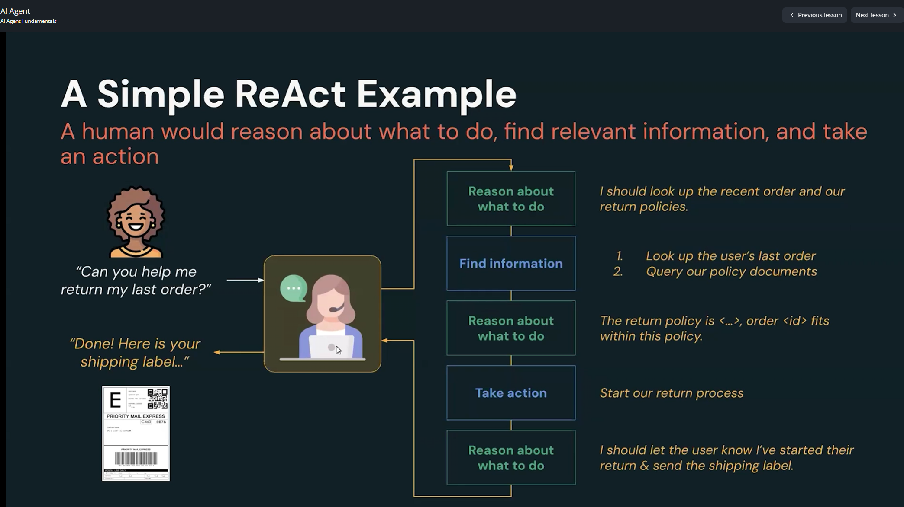

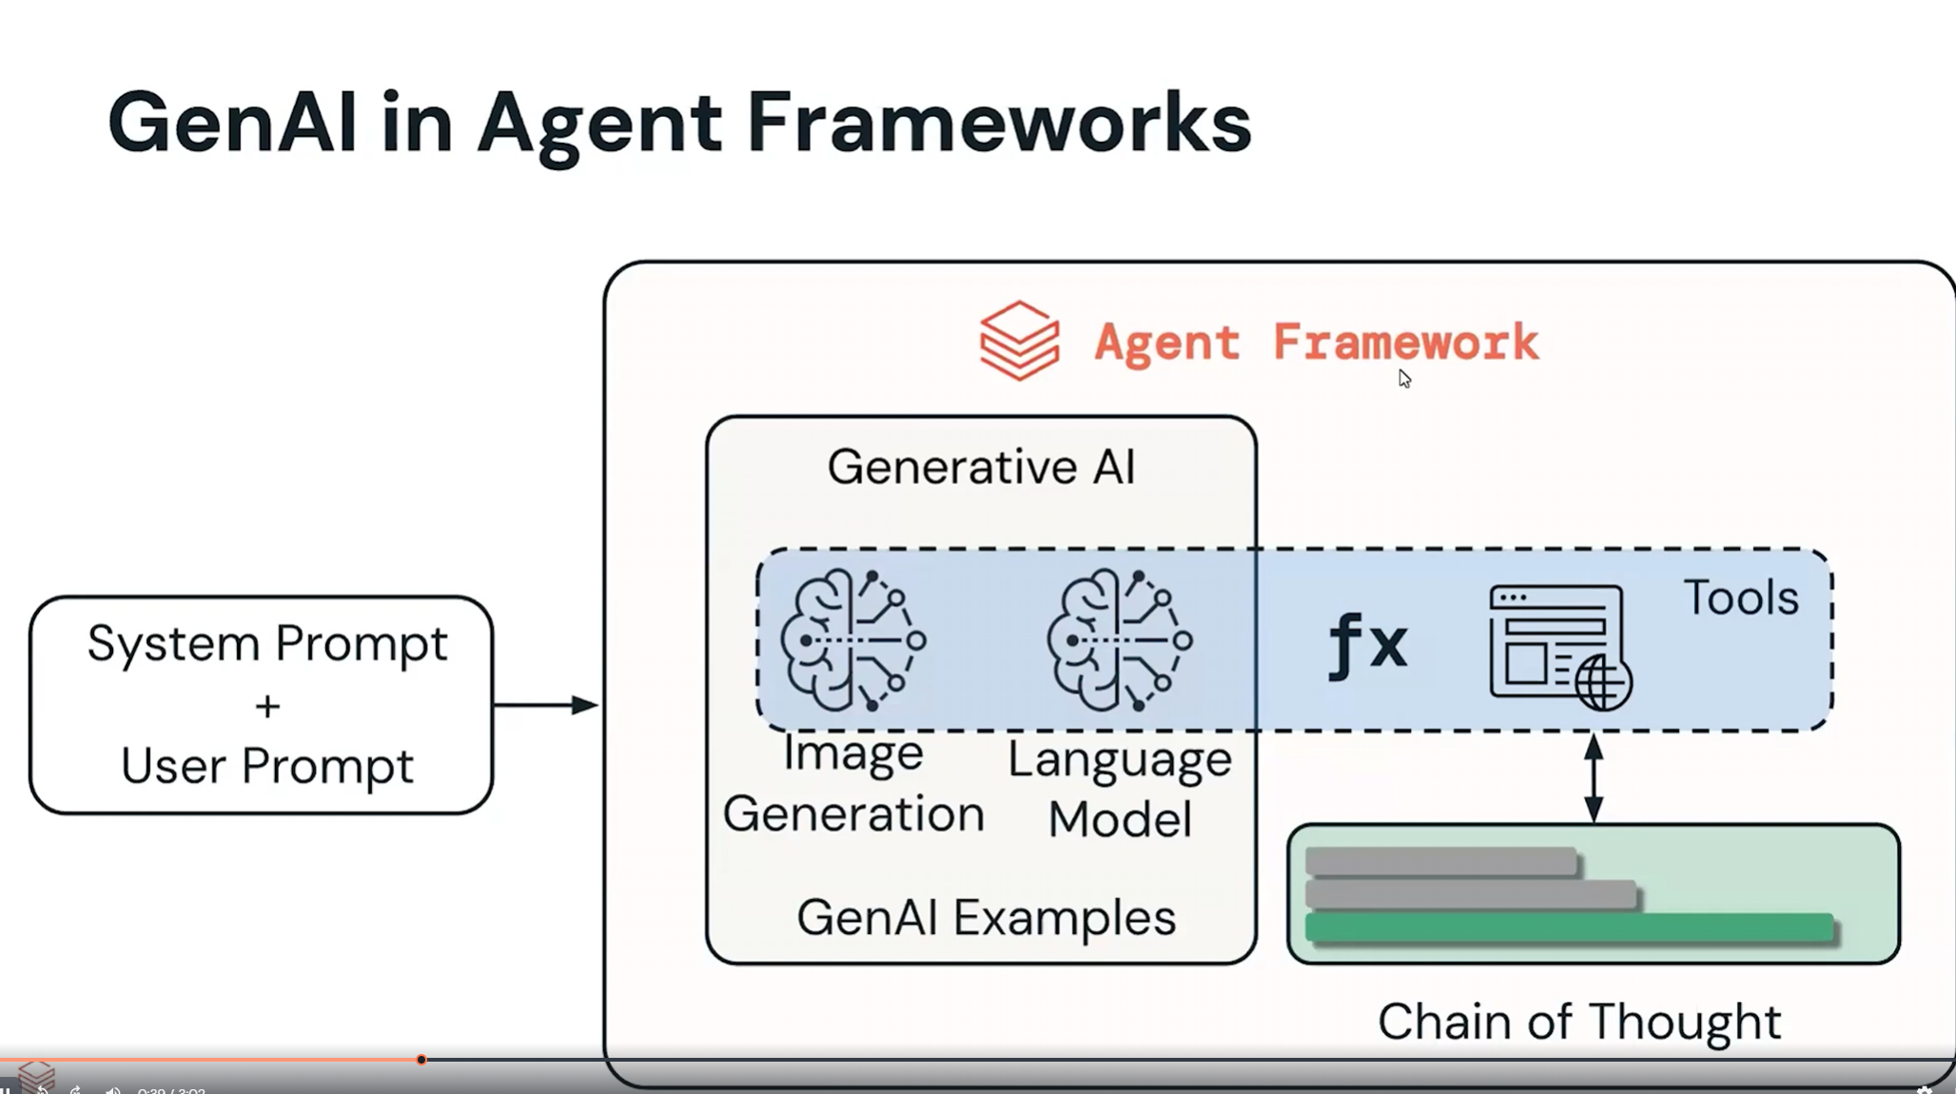

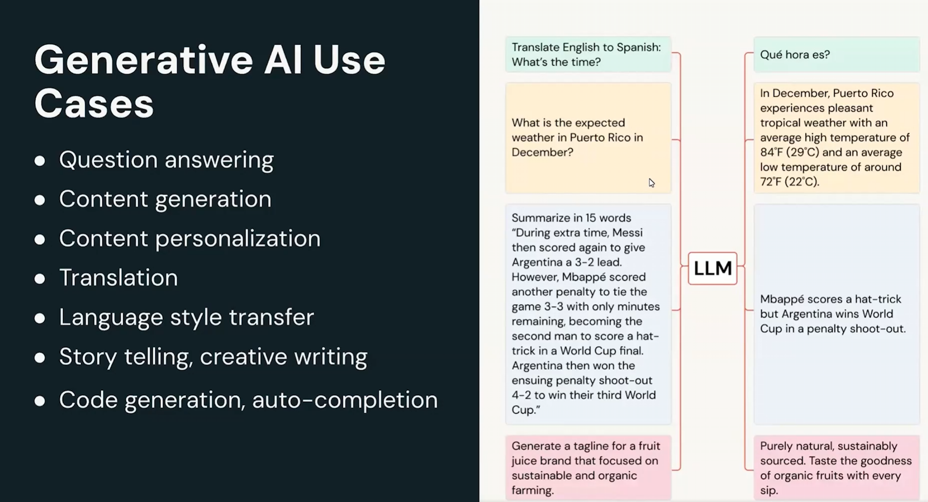

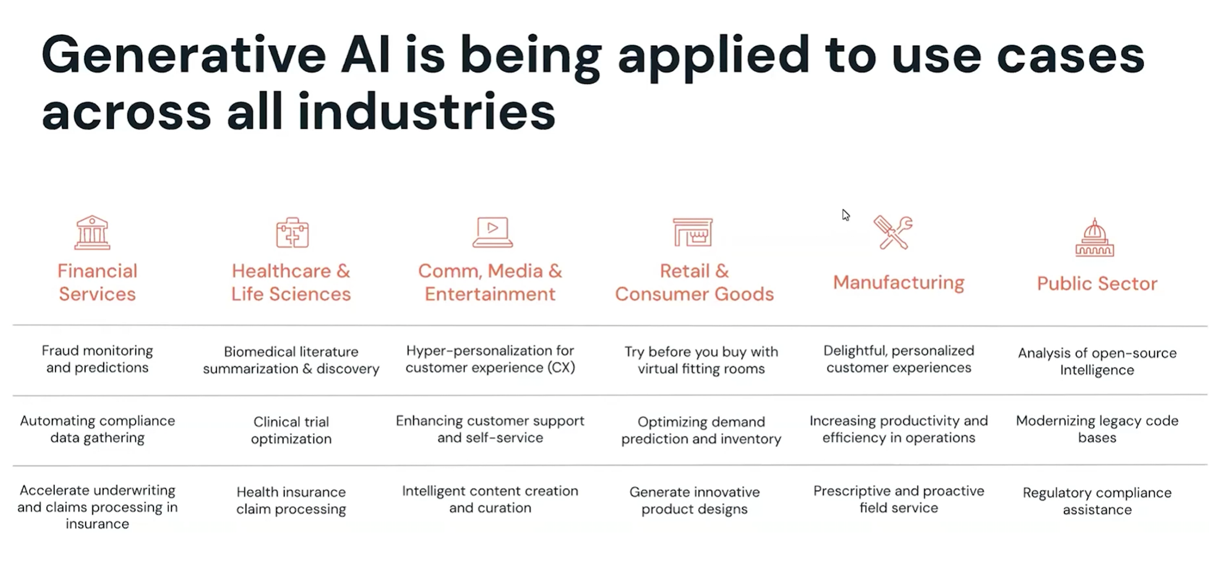

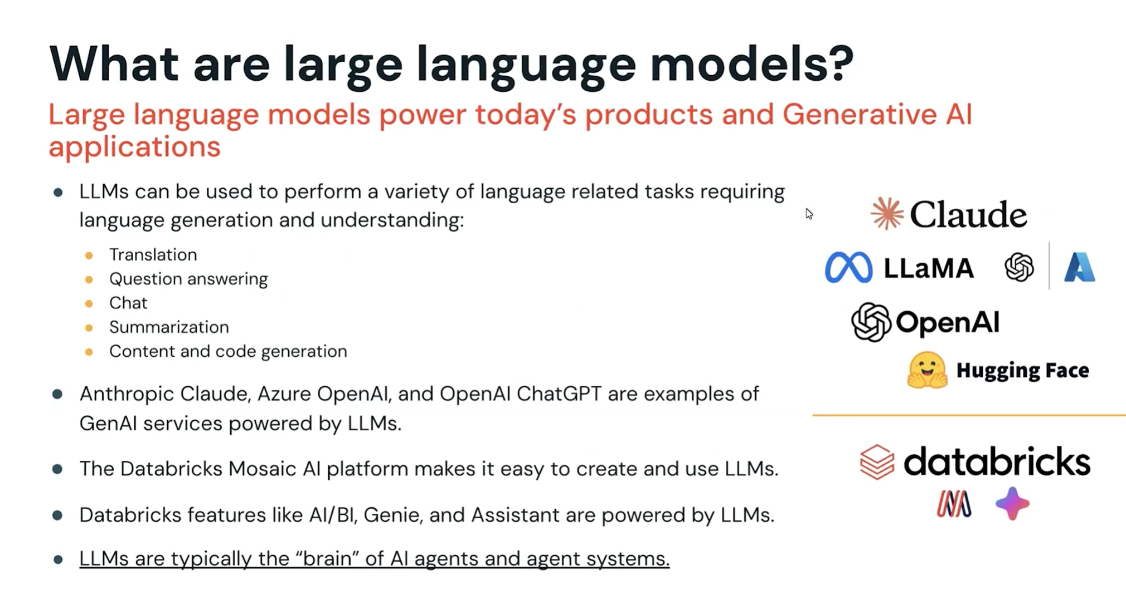

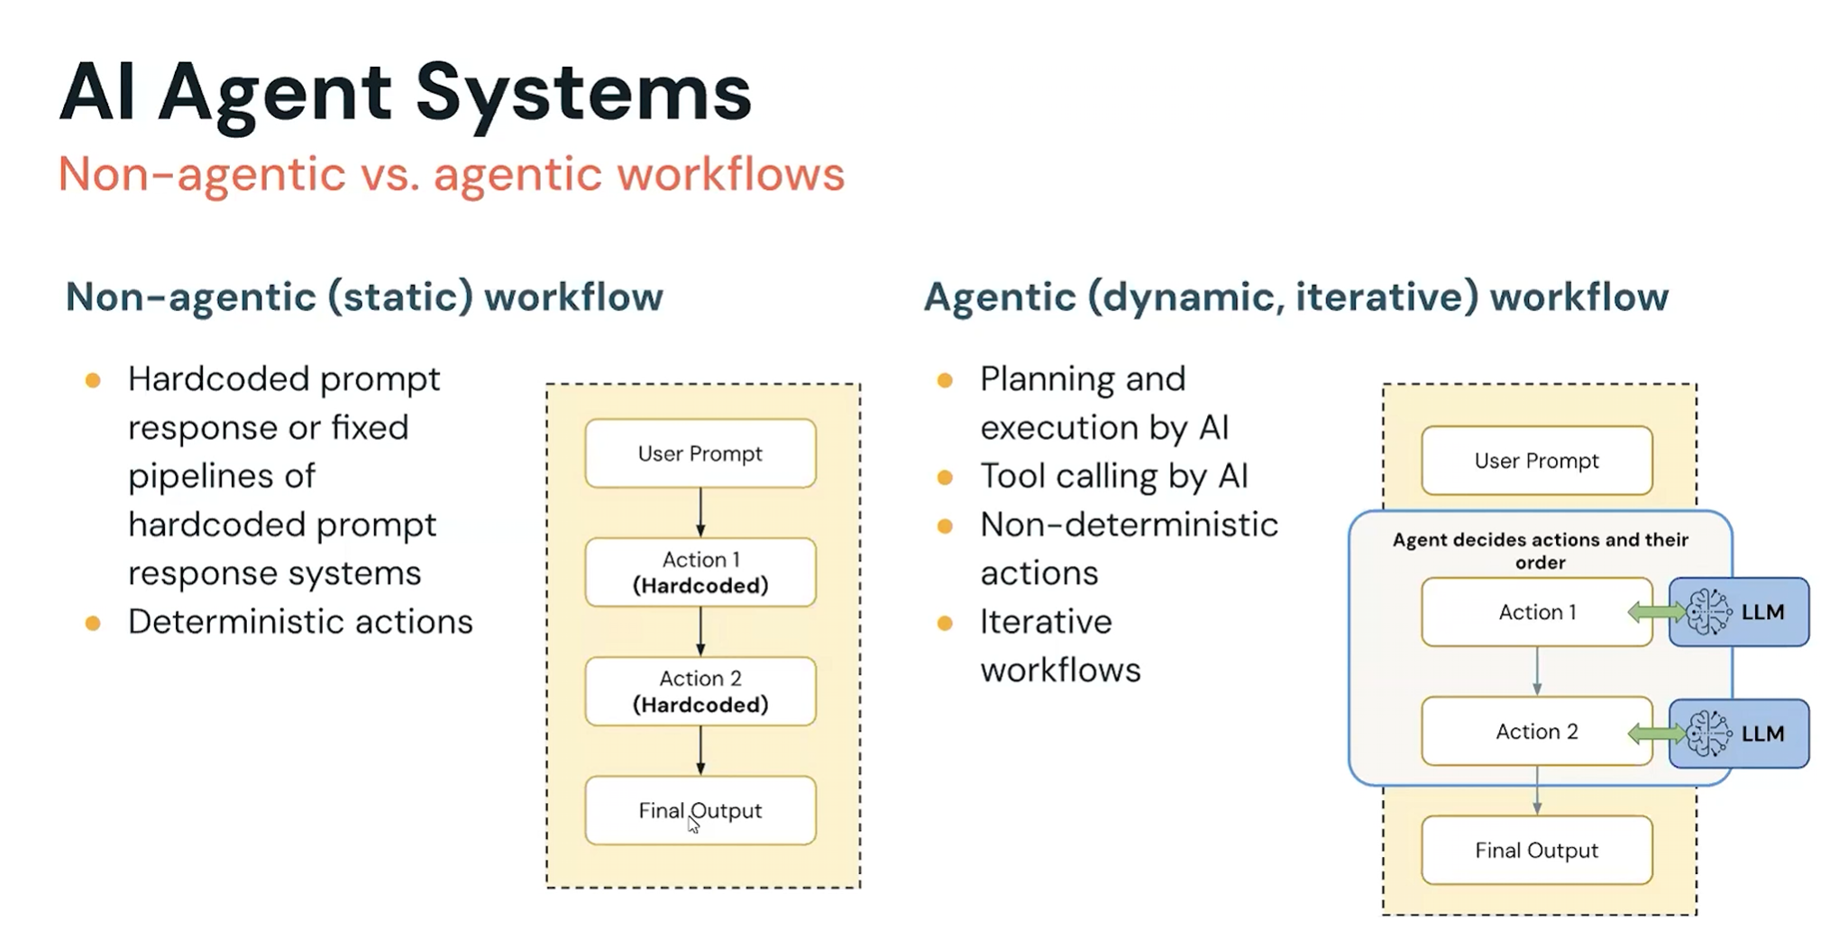

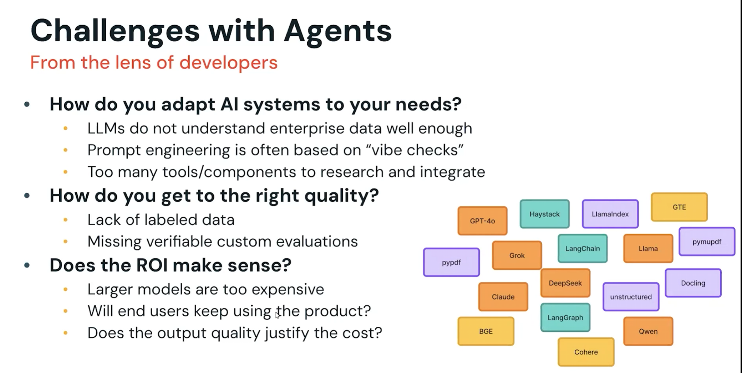

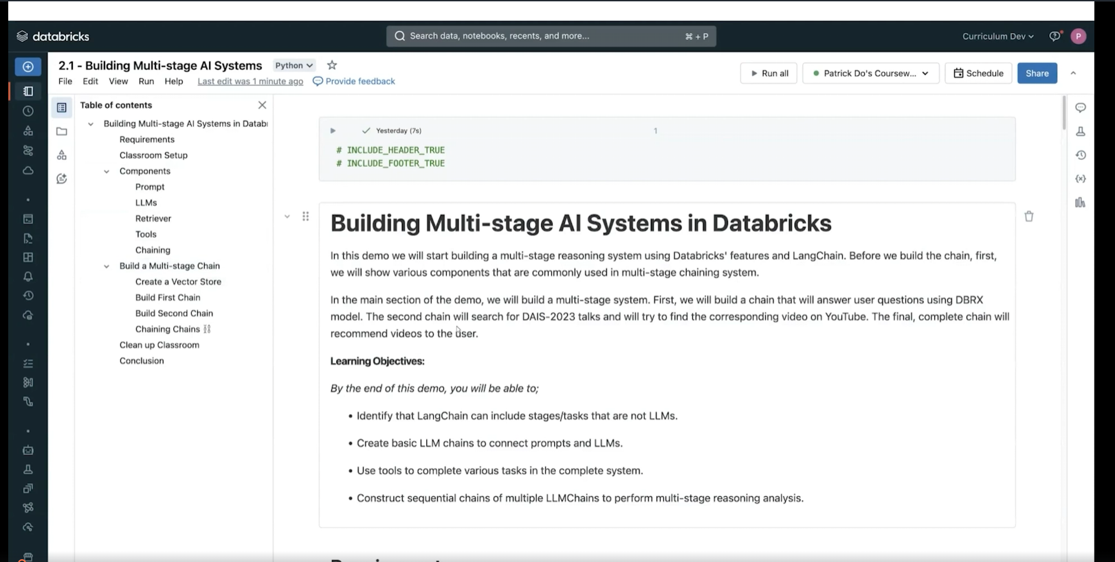

Vector Search

Documentation needed for how to use libraries

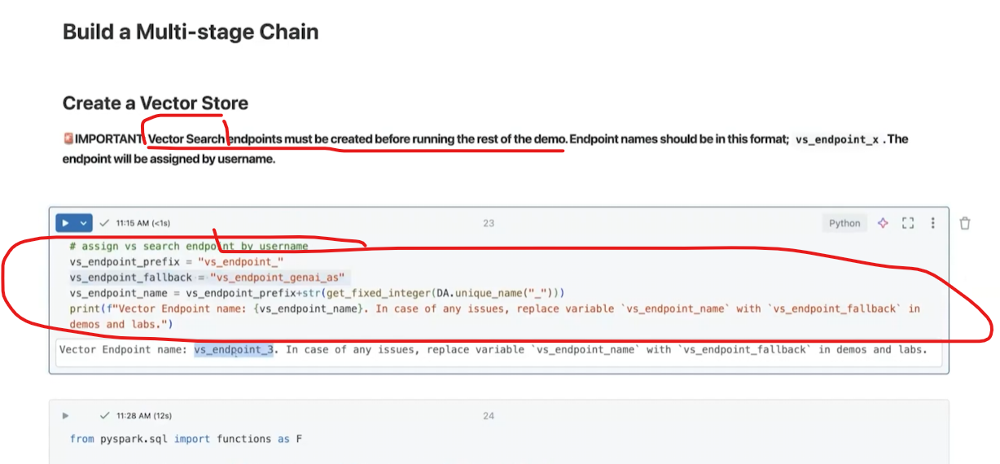

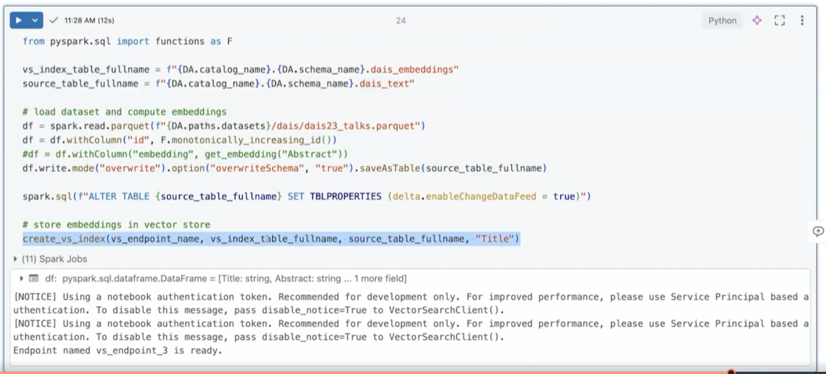

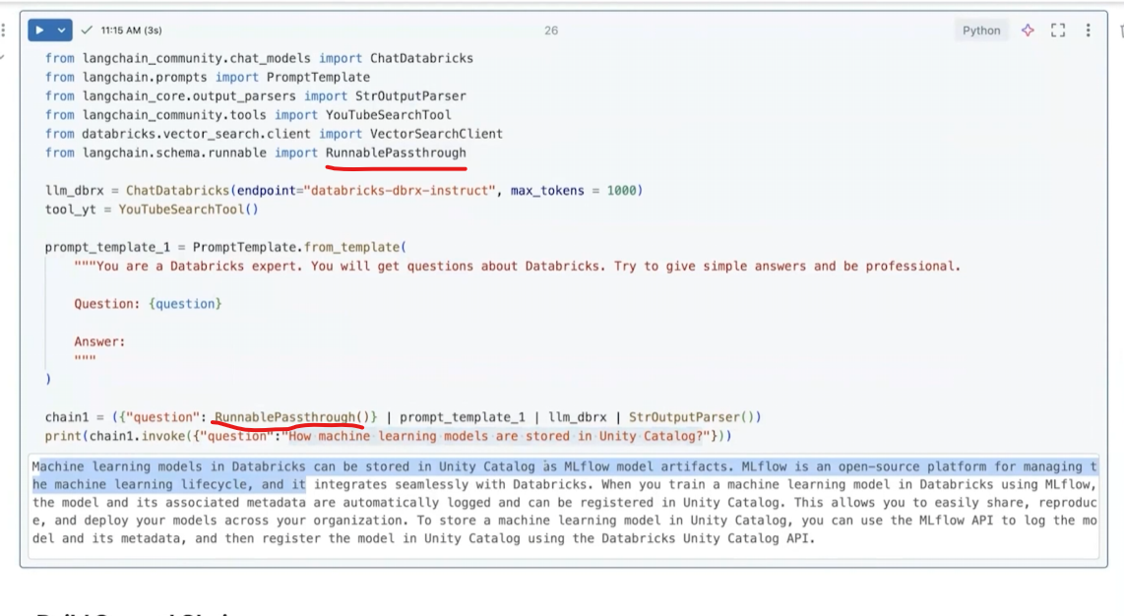

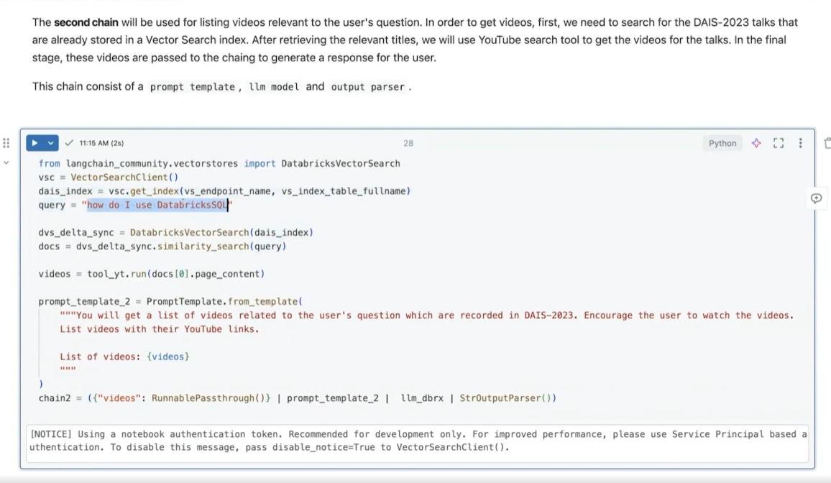

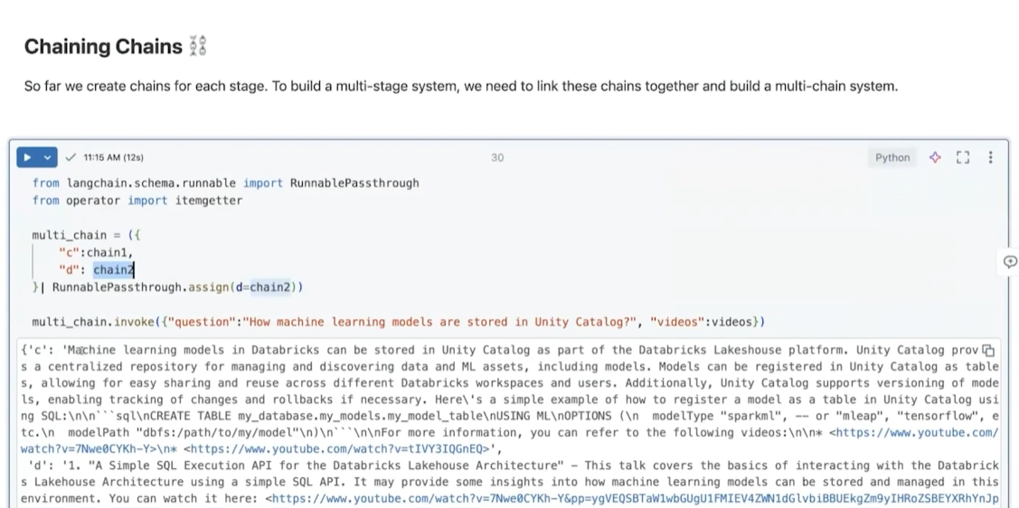

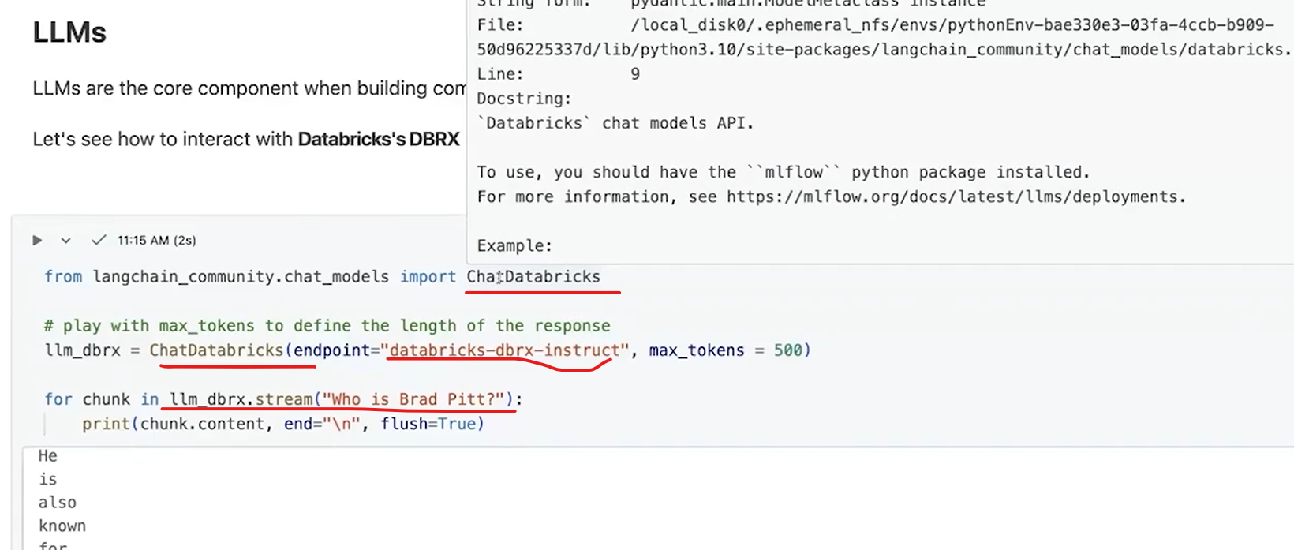

Second Example

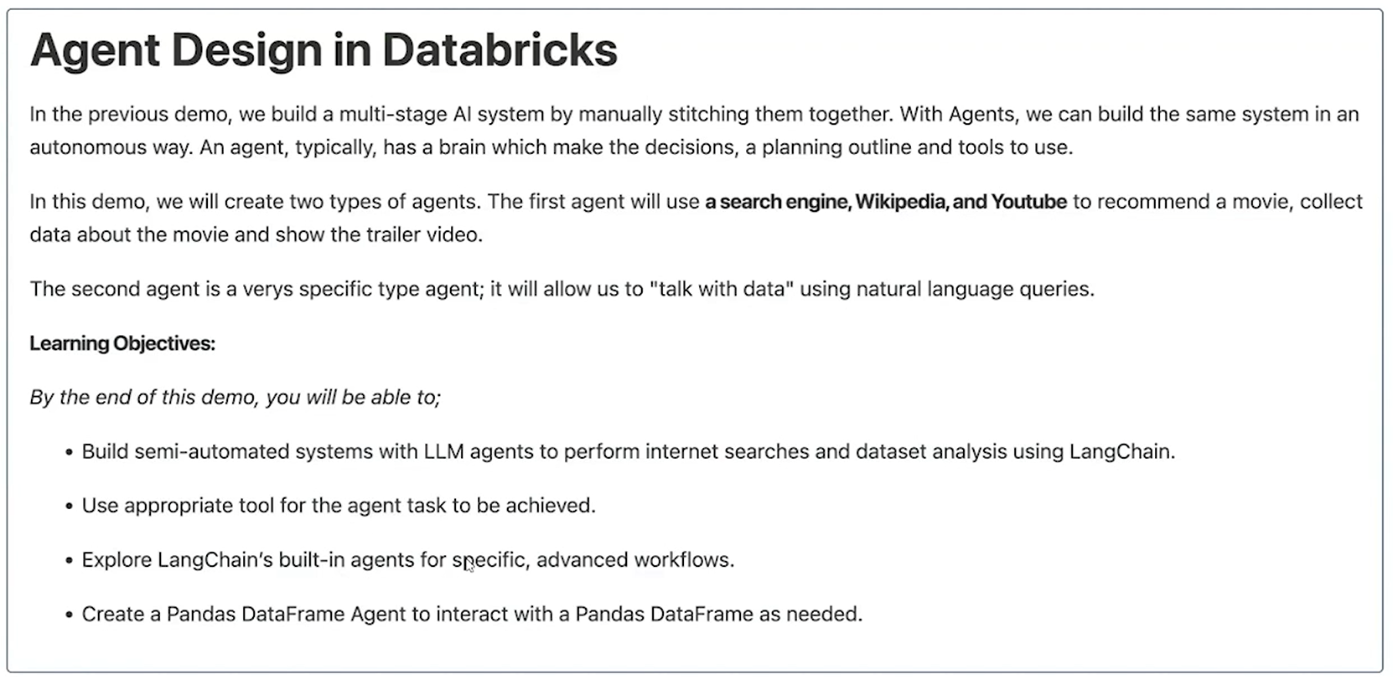

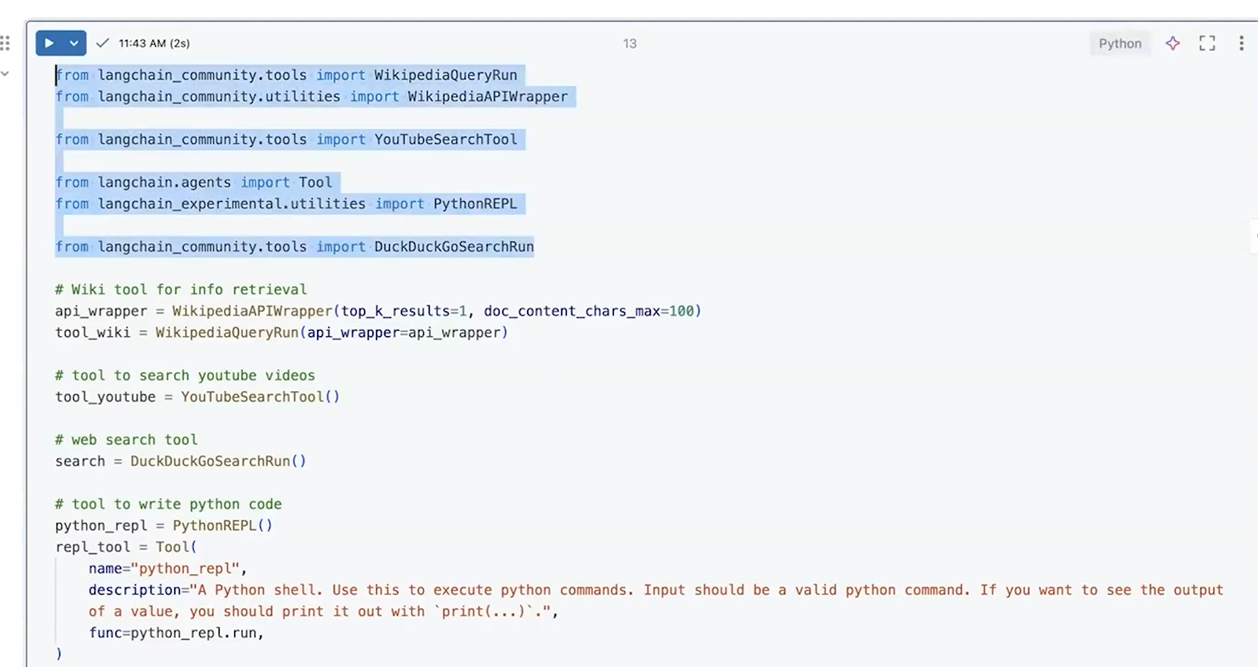

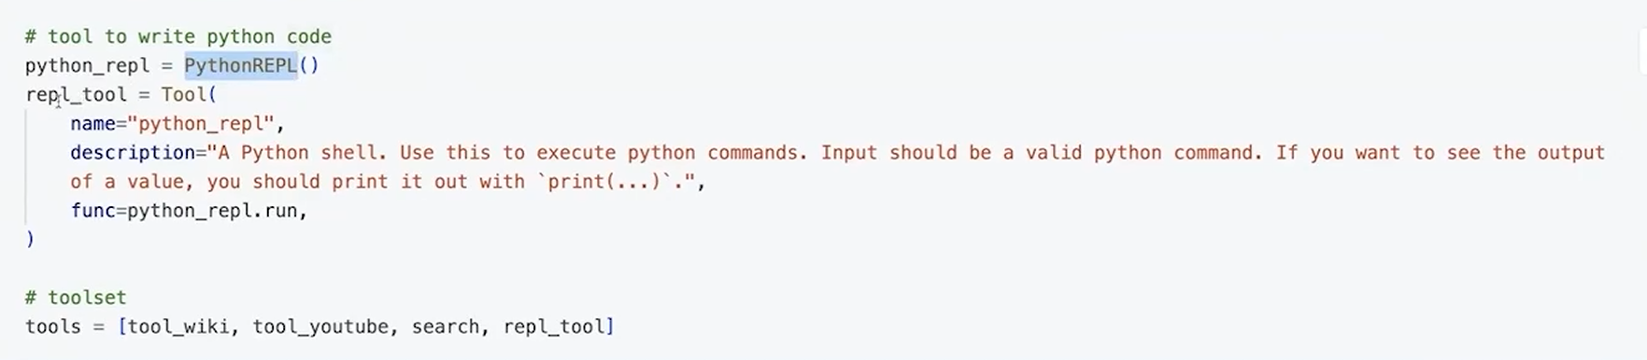

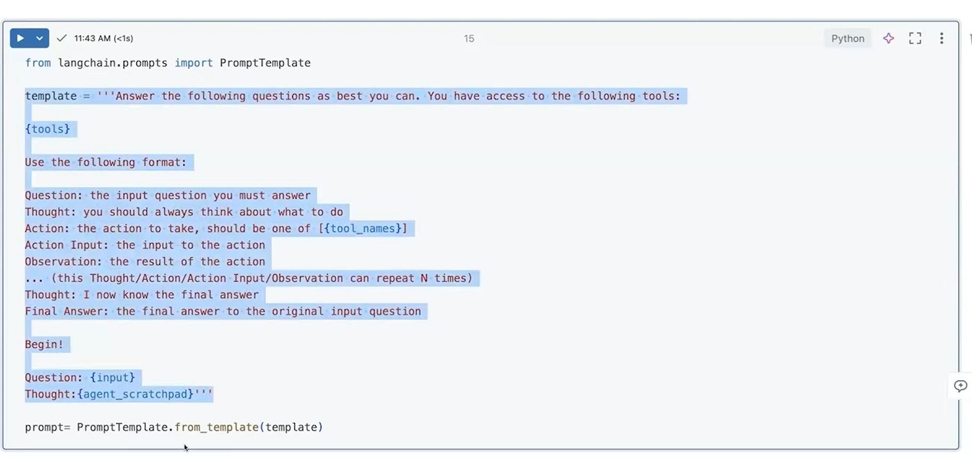

He used a ReAct agent because the task requires multi-step reasoning + dynamic tool usage + observation of results before deciding the next step.

**What ReAct means (important)**

**ReAct = Reason + Act + Observe**

Loop:

Thought → Action → Observation → Thought → Action → …

This is **not marketing**, it’s a control loop.

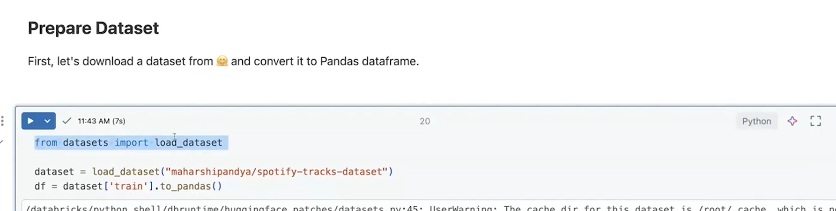

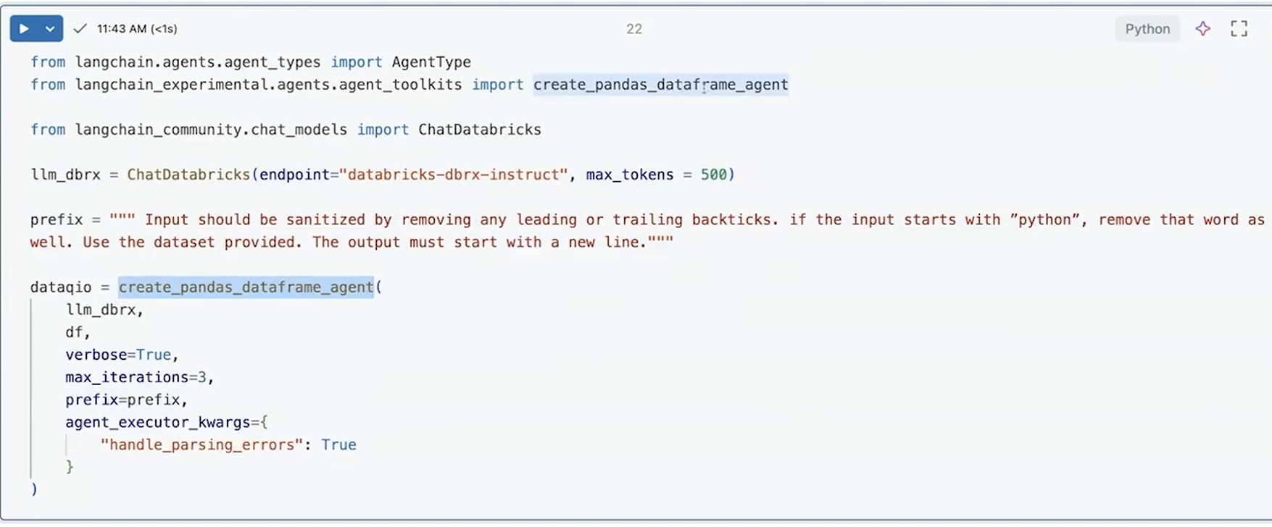

**Crew AI** is explicitly designed around the idea of **collaborative intelligence**:

* Multiple **autonomous AI agents**
* Each agent has a **role, goal, and responsibility**
* Agents **coordinate and collaborate** to solve complex tasks
* Emphasis is on **teamwork**, task delegation, and inter-agent communication

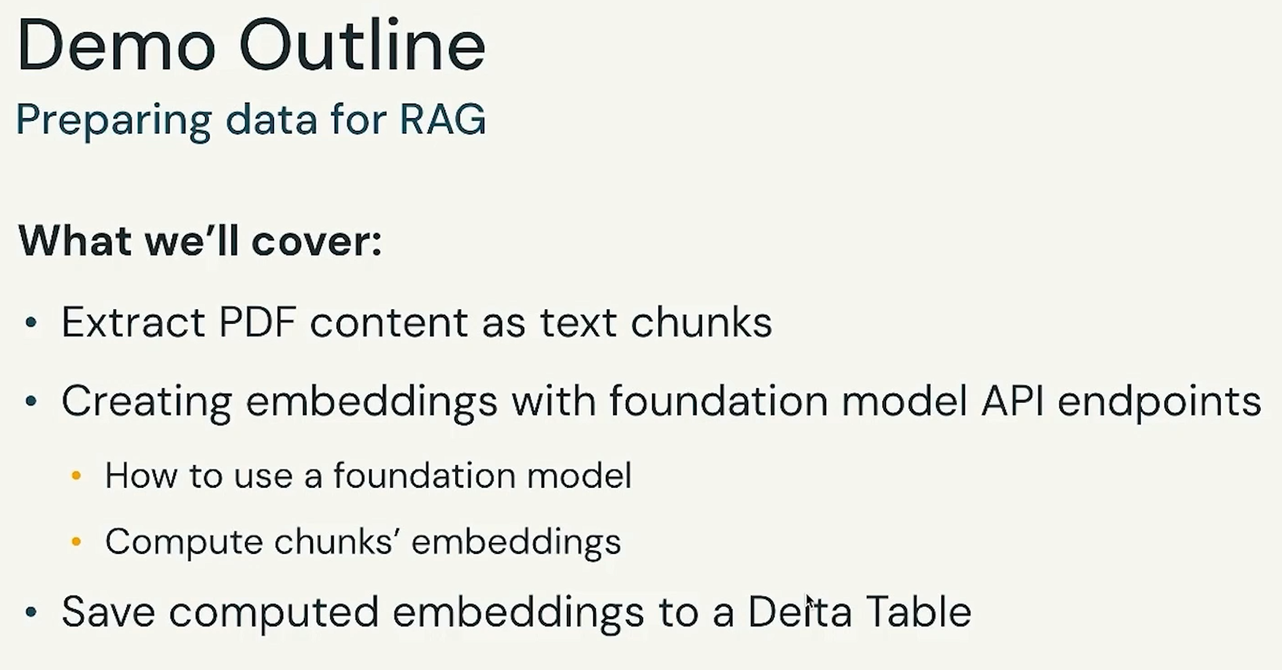

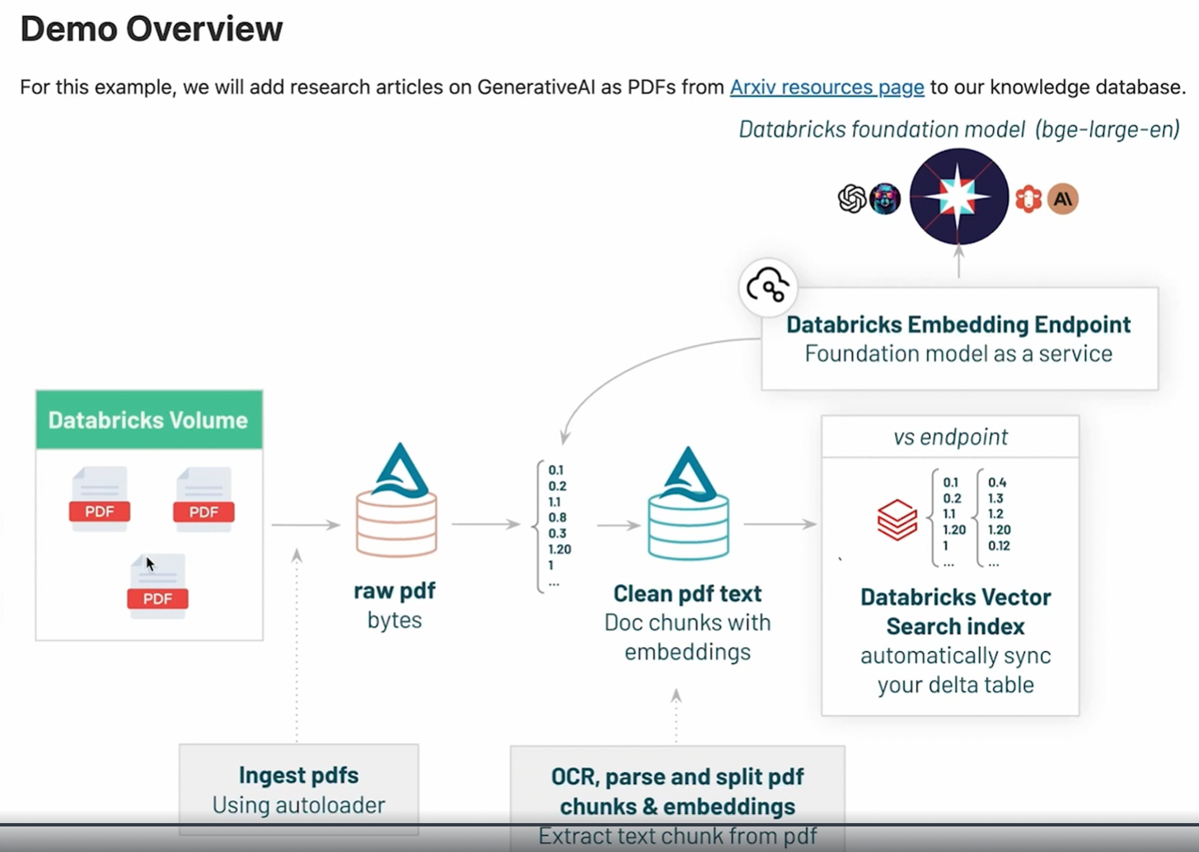

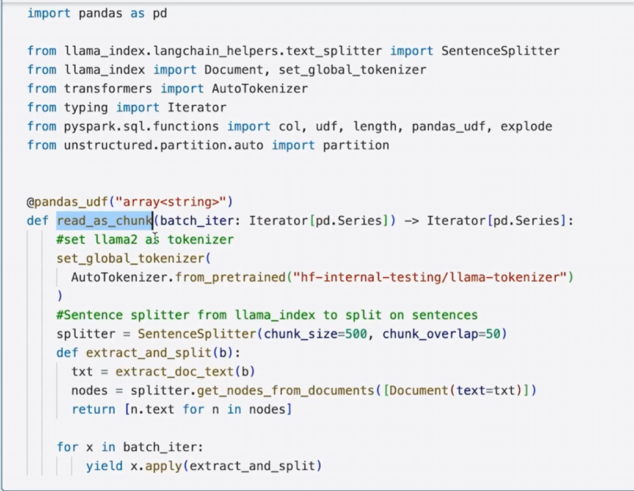

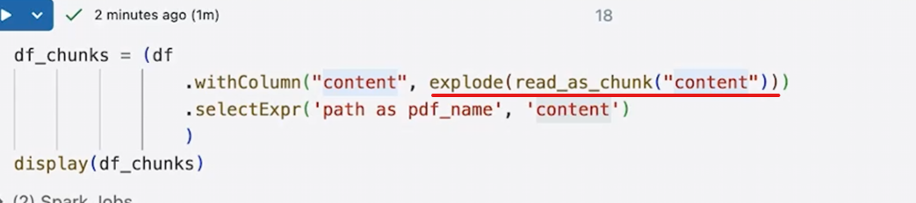

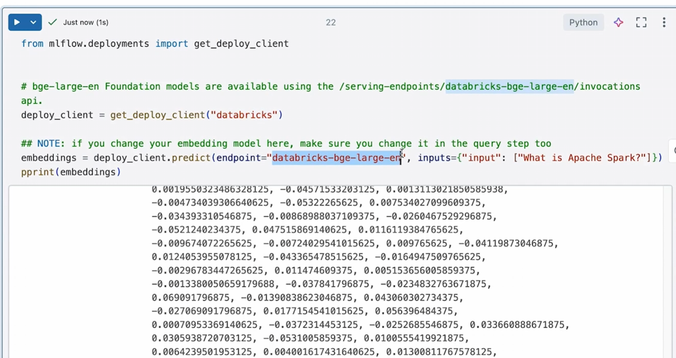

from mlflow.deployments import get_deploy_client

This gives you a generic client that knows how to talk to:

Databricks

SageMaker

Azure ML

etc.

Here, you’ll use it for Databricks.

deploy_client = get_deploy_client("databricks")

This means:

“I want to call models that are deployed on Databricks.”  
Under the hood:

* Uses your Databricks auth
* Knows how to hit Databricks serving endpoints
* Handles request/response formatting

embeddings = deploy_client.predict(

endpoint="databricks-bge-large-en",

inputs={"input": ["What is Apache Spark?"]}

)

his is the **core line**.

What’s happening:

**🔹 endpoint="databricks-bge-large-en"**

* This is a **Databricks-hosted embedding model**
* Based on **BGE (BAAI General Embedding)** family
* Managed and served by Databricks

You did **not** deploy this model — Databricks did.

**inputs={"input": [...]}**

You are sending:

{

"input": ["What is Apache Spark?"]

}

User text

↓

Databricks embedding endpoint (via MLflow client)

↓

Vector

↓

Stored in Vector DB (or searched against one)

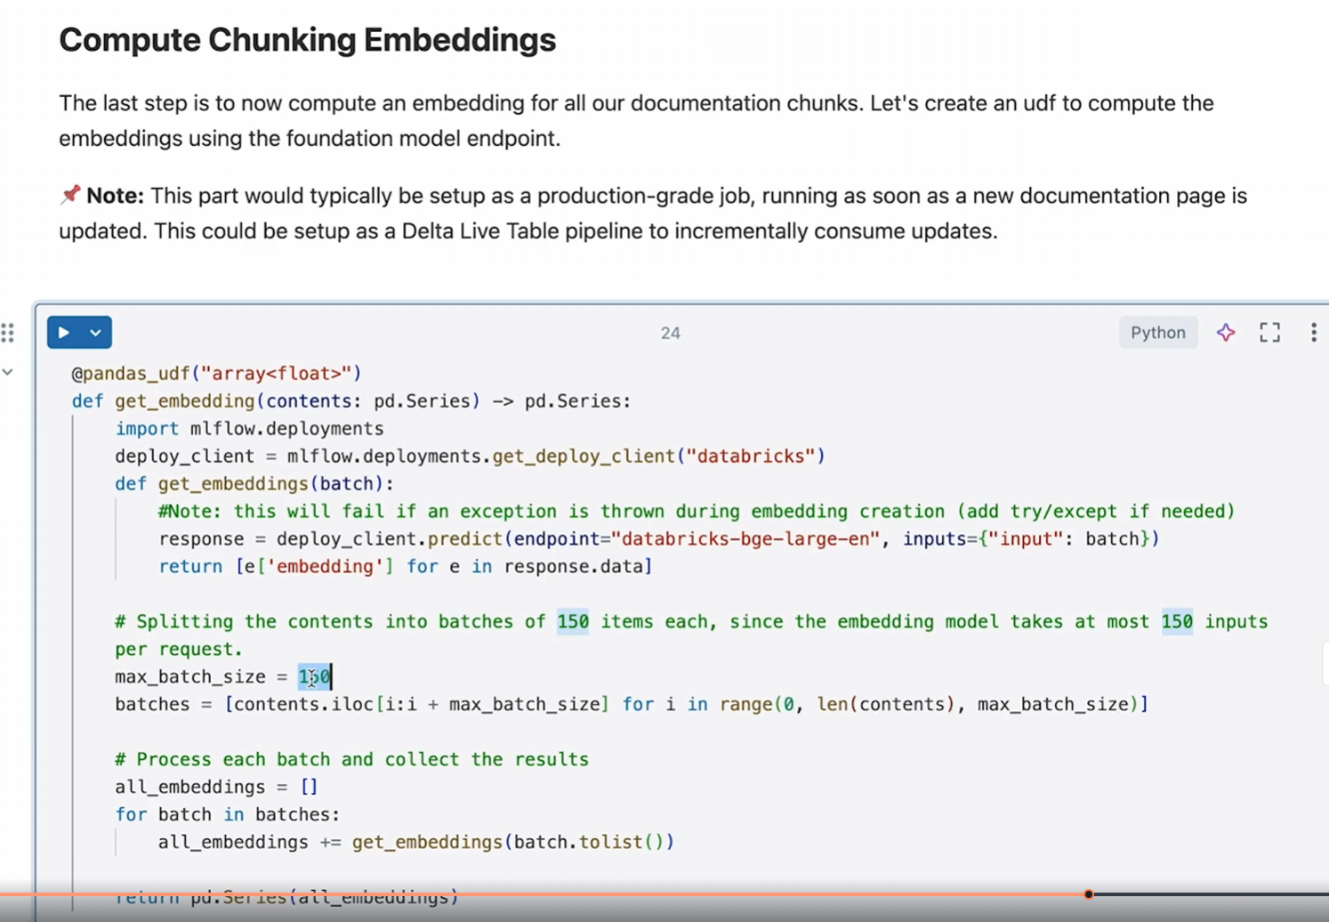

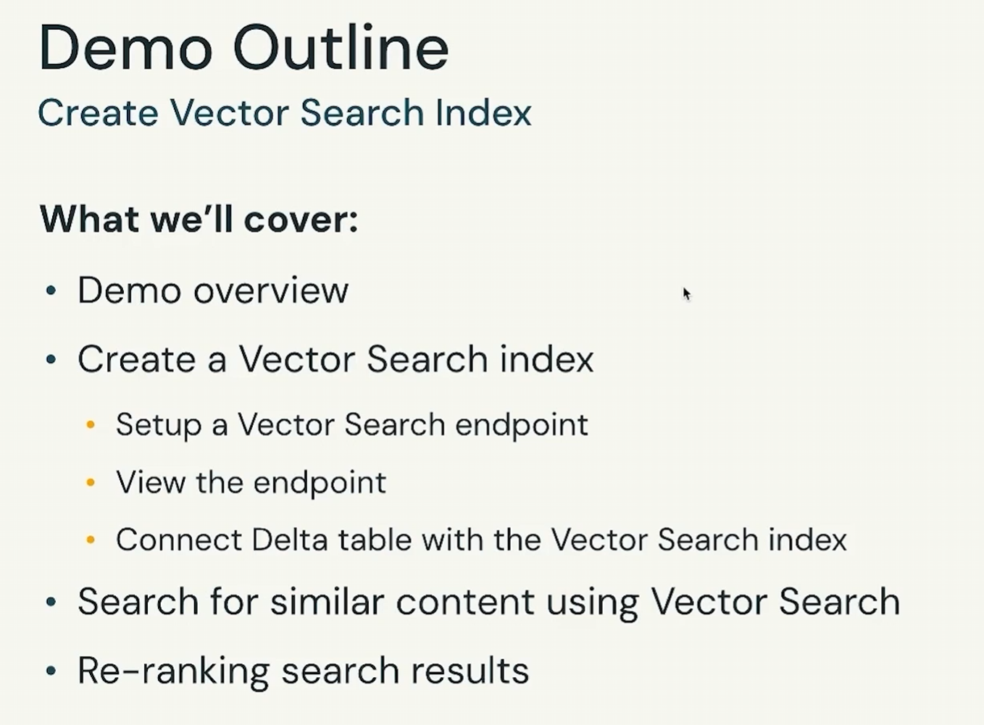

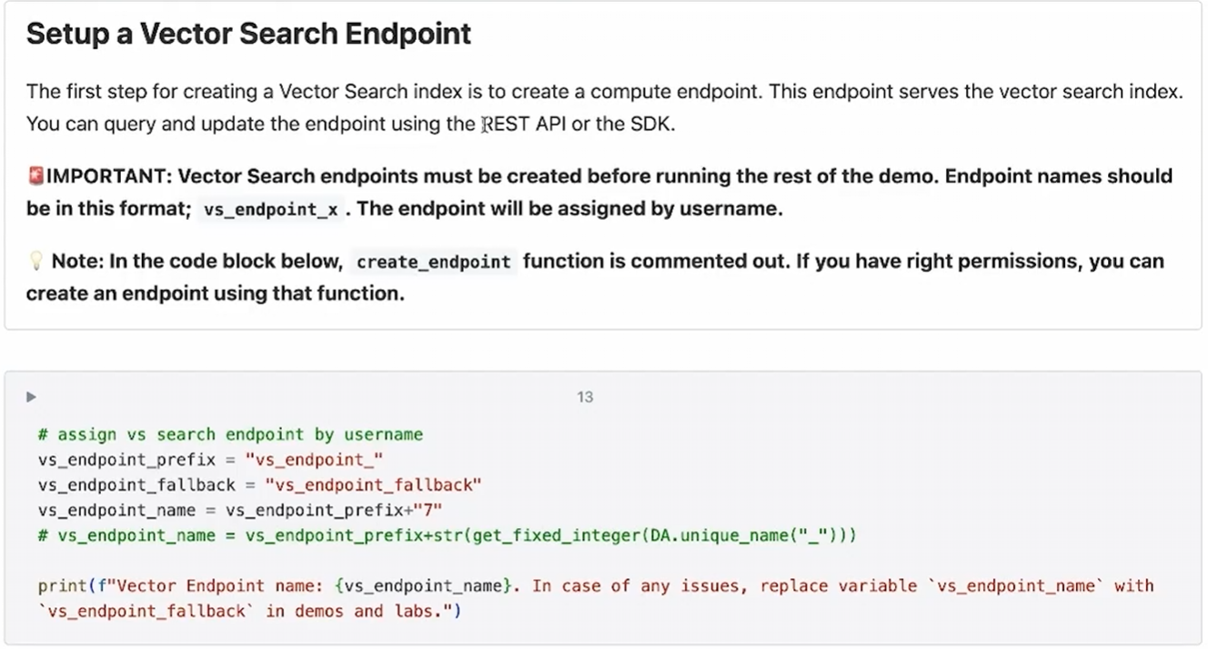

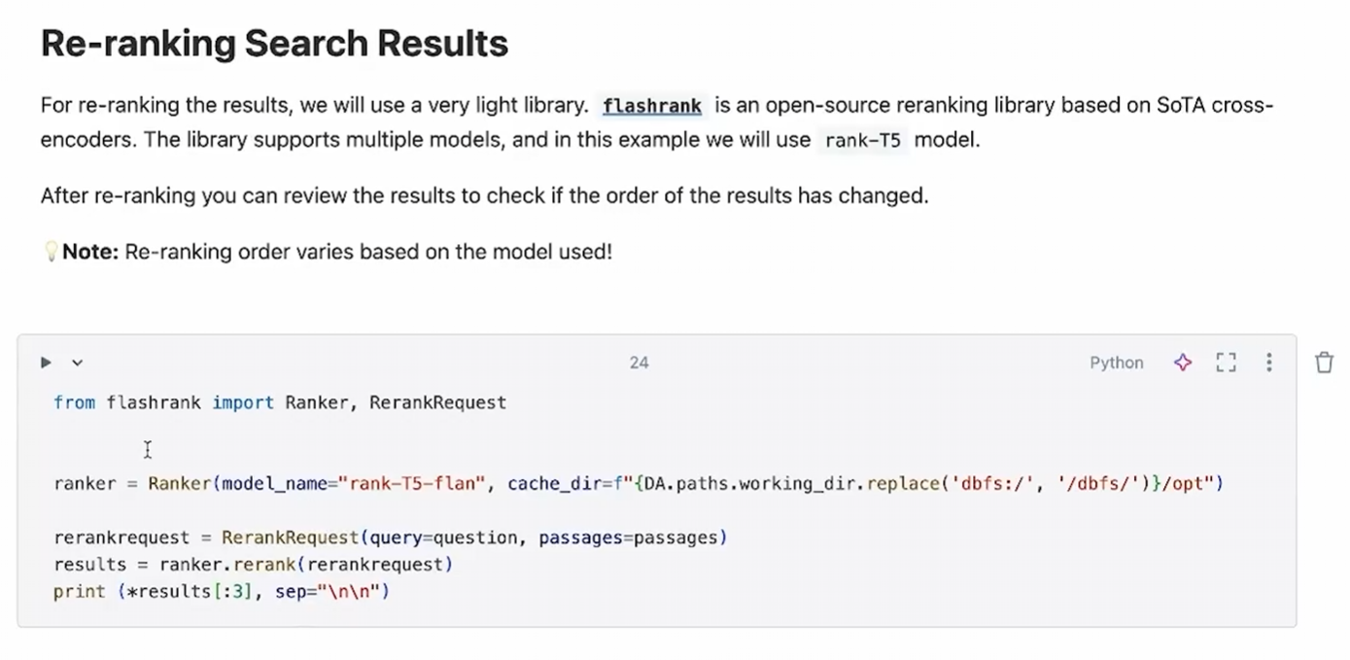

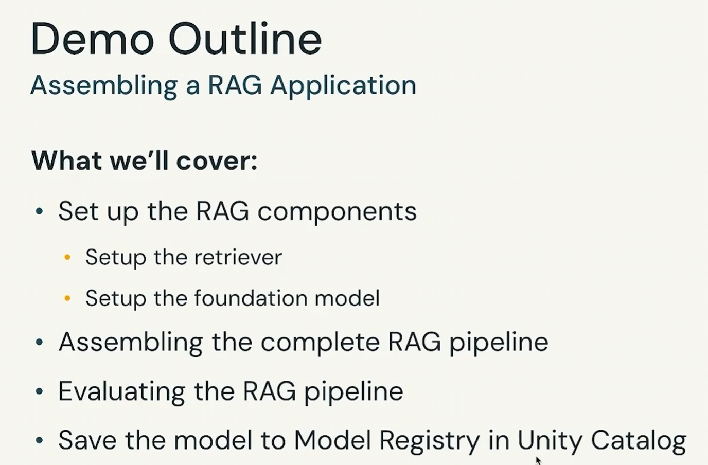

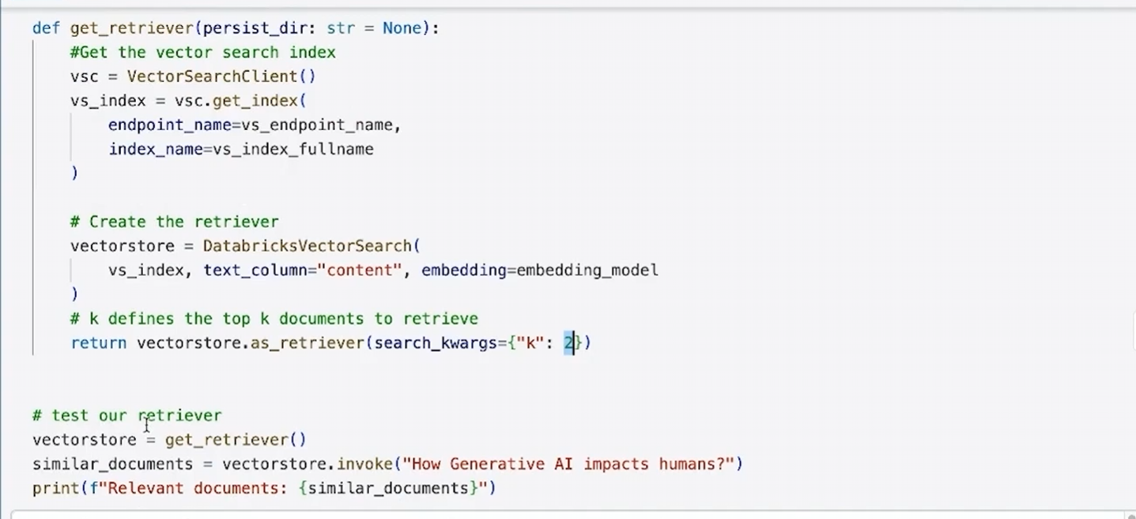

VectorSearchClient

↓

get_index()

↓

Databricks Vector Index

↓

DatabricksVectorSearch (LangChain wrapper)

↓

as_retriever(k=2)

↓

Retriever.invoke(query)

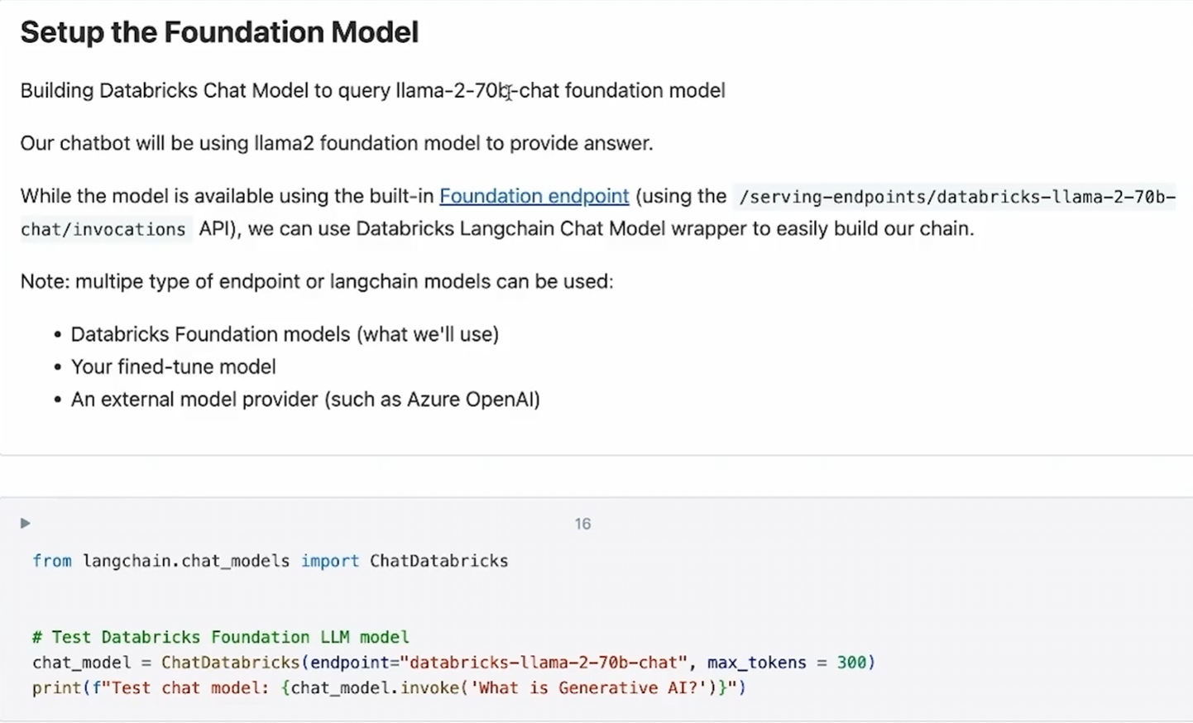

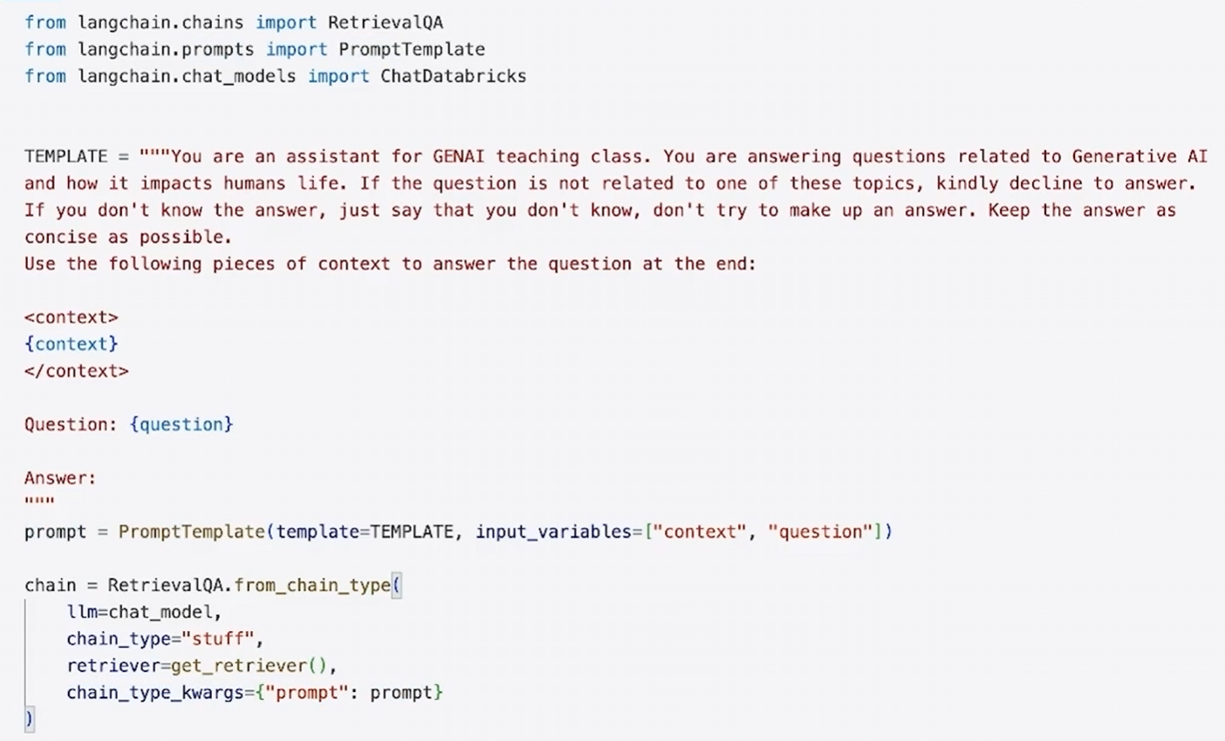

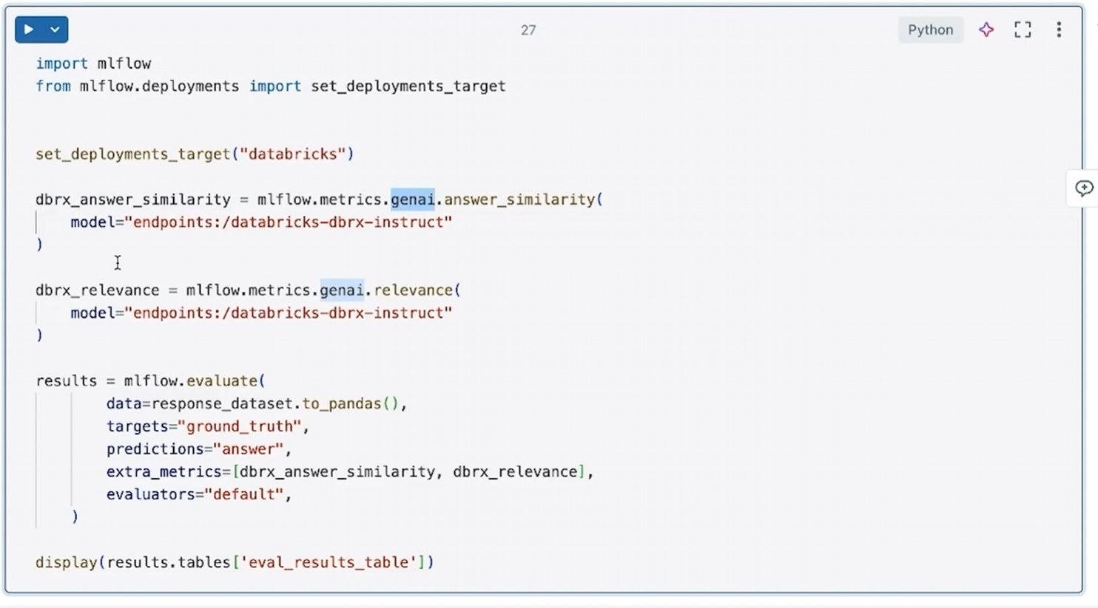

Great question — this is a **very Databricks-specific “aha” moment**, and once it clicks, a lot of their GenAI stack suddenly makes sense.

I’ll explain this in **layers**, then give you a **mental model + interview answer**.

**Short answer (TL;DR)**

**MLflow is Databricks’ control plane for evaluating, tracking, and governing GenAI systems** — not just models.

In this code, MLflow is being used to **evaluate LLM outputs** (answers) using **LLM-as-a-judge metrics** like:

* answer similarity
* relevance

**Why MLflow appears in Databricks GenAI workflows**

Databricks made a **deliberate design choice**:

“LLM apps are not just models — they are systems. We need to evaluate and track them like ML systems.”

So MLflow evolved from:

model tracking → experiment tracking → LLM system evaluation

That’s why MLflow now has:

mlflow.metrics.genai.*

**What this code is actually doing (step by step)**

**1️⃣ Tell MLflow where inference will run**

set_deployments_target("databricks")

This tells MLflow:

* “Use Databricks-hosted foundation models”
* Not OpenAI, not local

Think of this as **routing**, not evaluation.

**2️⃣ Define GenAI evaluation metrics (LLM-as-judge)**

dbx_answer_similarity = mlflow.metrics.genai.answer_similarity(

model="endpoints:/databricks-dbrx-instruct"

)

This means:

“Use the DBRX LLM itself to judge how similar the generated answer is to the ground truth.”

⚠️ Important:

* This is **not cosine similarity**
* This is **LLM-based semantic judgment**

Same for relevance:

dbx_relevance = mlflow.metrics.genai.relevance(

model="endpoints:/databricks-dbrx-instruct"

)

That asks the LLM:

“Is this answer relevant to the question?”

**3️⃣ Evaluate a dataset of LLM responses**

results = mlflow.evaluate(

data=response_dataset.to_pandas(),

targets="ground_truth",

predictions="answer",

extra_metrics=[dbx_answer_similarity, dbx_relevance],

evaluators="default",

)

This does **batch evaluation**.

Your dataset looks conceptually like:

| **question** | **ground_truth** | **answer** |
| --- | --- | --- |
| Q1 | correct answer | model answer |
| Q2 | correct answer | model answer |

MLflow now:

* Runs evaluators row-by-row
* Calls DBRX to judge each answer
* Stores structured results

**4️⃣ Display evaluation results**

display(results.tables['eval_results_table'])

This shows:

* Per-row scores
* Aggregate metrics
* Failure cases

This is **LLM evaluation**, not inference.

**Why Databricks uses MLflow for this (key insight)**

Databricks wants:

✅ Reproducibility  
✅ Governance  
✅ Auditability  
✅ Comparability across versions

MLflow gives them:

* Versioned evaluations
* Logged metrics
* Experiment comparison
* Production safety checks

Prompt tuning, RAG changes, retriever swaps → **all become trackable experiments**

**How this fits into a real GenAI lifecycle**

Chunking → Embedding → Vector Search → RAG → LLM Output

↓

MLflow Evaluation

↓

Quality Gates / Promotion

This is **production GenAI**, not notebooks.

**Key distinction (very important)**

| **Thing** | **Purpose** |
| --- | --- |
| Inference | Generate answers |
| Vector search | Retrieve context |
| MLflow evaluate | Measure quality |
| MLflow tracking | Compare versions |

MLflow does **NOT**:

* Retrieve documents
* Generate answers (except as a judge)

**Interview-ready explanation**

“Databricks uses MLflow to evaluate LLM systems using LLM-as-a-judge metrics like relevance and answer similarity. This allows them to track, compare, and govern RAG and agent outputs as reproducible experiments rather than ad-hoc prompt testing.”

**One-line analogy**

MLflow is **CI/CD for GenAI quality**.

**Why this matters in practice**

Without MLflow:

* You rely on human spot-checks
* No regression detection
* No promotion criteria

With MLflow:

* Automated quality gates
* Side-by-side model comparisons
* Safe production rollout

If you want next, I can:

* Draw the **full Databricks GenAI architecture**
* Explain **LLM-as-judge pitfalls**
* Compare **MLflow eval vs RAGAS**
* Show how this integrates with **LangChain / LangGraph**

You’re asking exactly the right questions — this is senior-level GenAI understanding 👏

**Generative AI Solution Development**

**Key Resources**

Below are some of the resources used throughout this course to support your learning and practical exercises.

**Lecture:** Prompt Engineering Primer

* [What is Retrieval Augmented Generation (RAG)? | Databricks](https://www.databricks.com/glossary/retrieval-augmented-generation-rag)
* [A Survey of Techniques for Maximizing LLM Performance](https://www.youtube.com/watch?v=ahnGLM-RC1Y&list=PLOXw6I10VTv-exVCRuRjbT6bqkfO74rWz&index=5)
* [Large language models are zero-shot reasoners | OpenReview](https://openreview.net/pdf?id=e2TBb5y0yFf)
* **Paper 1:** [Language models don't always say what they think: Unfaithful explanations in chain-of-thought prompting | arXiv](https://arxiv.org/abs/2305.04388)
* **Paper 2:** [Measuring faithfulness in chain-of-thought reasoning | arXiv](https://arxiv.org/abs/2307.13702)
* **Paper 3:** [LLMs with Chain-of-Thought Are Non-Causal Reasoners | arXiv](https://arxiv.org/html/2402.16048v1)

**Lecture:** Introduction to RAG

* [Lost in the Middle: How Language Models Use Long Contexts | arXiv](https://arxiv.org/pdf/2307.03172)
* [Git Repo: LLMTest_NeedleInAHaystack (branch: main) | gkamradt](https://github.com/gkamradt/LLMTest_NeedleInAHaystack.git)
* [Retrieval-Augmented Generation for Knowledge-Intensive NLP Tasks | arXiv](https://arxiv.org/abs/2005.11401)

**Lecture:** Preparing Data for RAG Solutions

* [Lost in the Middle: How Language Models Use Long Contexts | arXiv](https://arxiv.org/pdf/2307.03172)
* [Git Repo: LLMTest_NeedleInAHaystack (branch: main) | gkamradt](https://github.com/gkamradt/LLMTest_NeedleInAHaystack.git)
* [ChunkViz](https://chunkviz.up.railway.app/)

**Lecture:** Introduction to Vector Stores

* [Understanding Cosine Similarity and Its Applications | Built In](https://builtin.com/machine-learning/cosine-similarity)
* [Git Repo: annoy (branch: main) | spotify](https://github.com/spotify/annoy.git)
* [Efficient and robust approximate nearest neighbor search using Hierarchical Navigable Small World graphs | arXiv](https://arxiv.org/abs/1603.09320)
* [Git Repo: faiss (branch: main) | facebookresearch](https://github.com/facebookresearch/faiss.git)
* [Locality-sensitive hashing | Wikipedia](https://en.wikipedia.org/wiki/Locality-sensitive_hashing)
* [Announcing ScaNN: Efficient Vector Similarity Search | Google Research Blog](https://research.google/blog/announcing-scann-efficient-vector-similarity-search/)
* [Vector Search Explained | Weaviate](https://weaviate.io/blog/vector-search-explained)
* [Hierarchical Navigable Small Worlds (HNSW) | Pinecone](https://www.pinecone.io/learn/series/faiss/hnsw/)
* [IVFPQ + HNSW for Billion-scale Similarity Search | Towards Data Science](https://towardsdatascience.com/ivfpq-hnsw-for-billion-scale-similarity-search-89ff2f89d90e)
* [Understanding Hierarchical Navigable Small Worlds (HNSW) - Zilliz Learn](https://zilliz.com/blog/hierarchical-navigable-small-worlds-HNSW)

**Product Quantization (PQ)** is all about **efficiency at scale**.

* Embeddings are usually **high-dimensional** (e.g. 768, 1024, 1536 dims)
* Storing and comparing them exactly is **memory- and compute-expensive**
* PQ **compresses vectors** into small codes while preserving approximate distances

This allows:

* Much **lower RAM usage**
* Faster **Approximate Nearest Neighbor (ANN)** search
* Large-scale vector search (millions or billions of vectors)